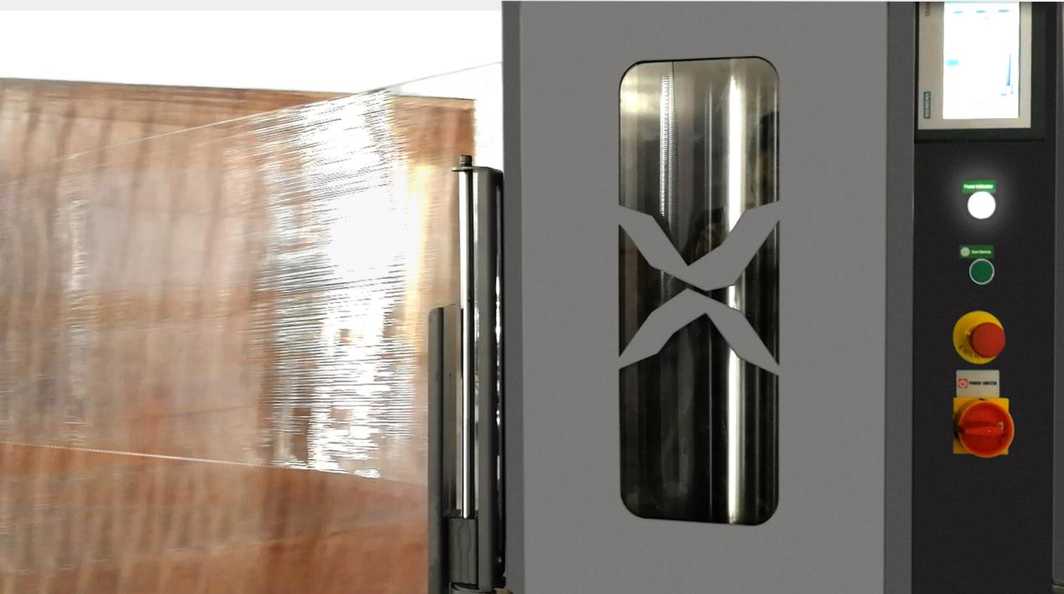

300% Pre-stretch Rate.

Smart wasp Film carriage use the rubber stretch roller ,roller lifter much longer .film can be average stretched 300% rate .

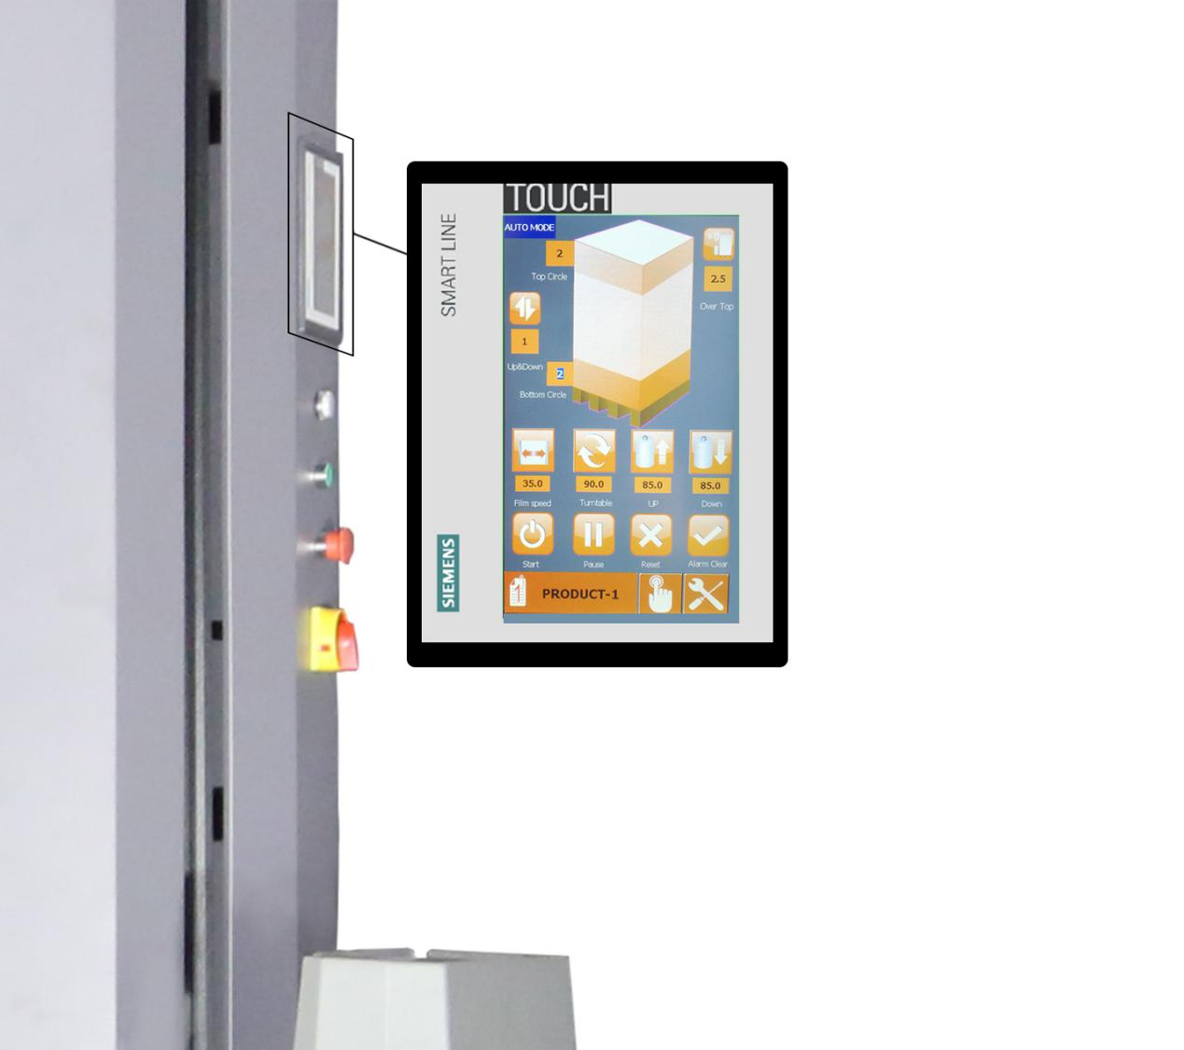

SIEMENS Touch Operating System

Intuitive, easy to understand,has nothing to do with language and skills.

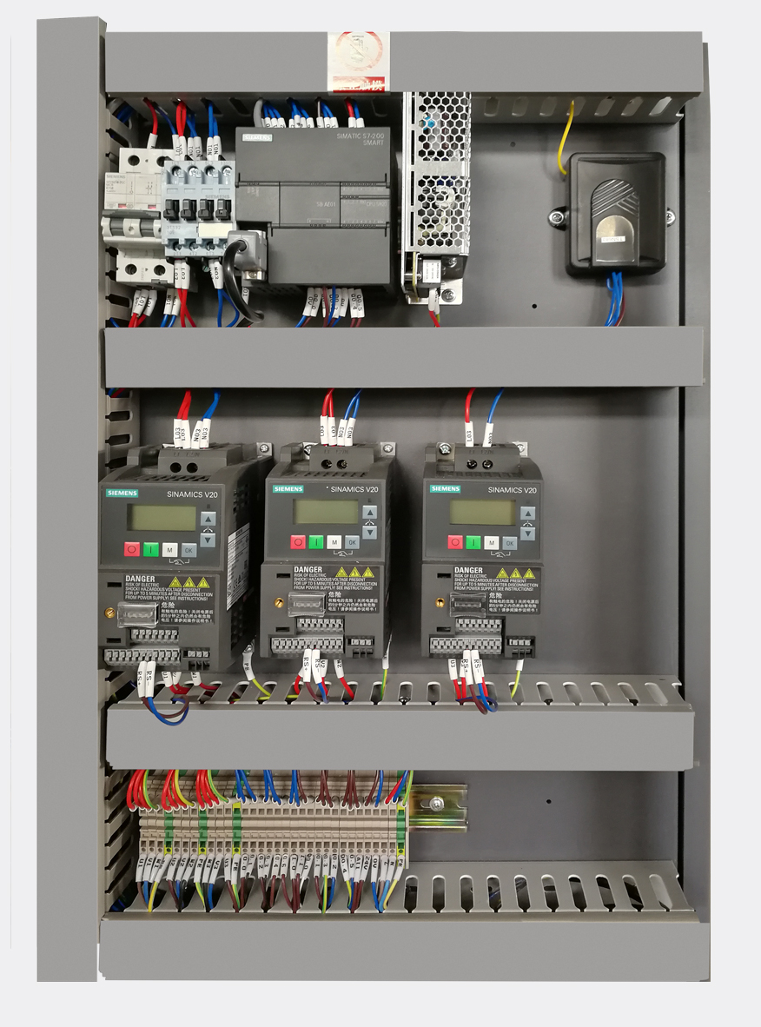

Powerful Control System

SIEMENS PLC ,SIEMENS Inverter，SIEMENS AIR Breaker ，SIEMENS Contactor ,Germany SICK Brand Sensor，Germany Weidmuller terminal black ,OMRON 24V power supplier ,Schneider button ,Better spare parts, better products.

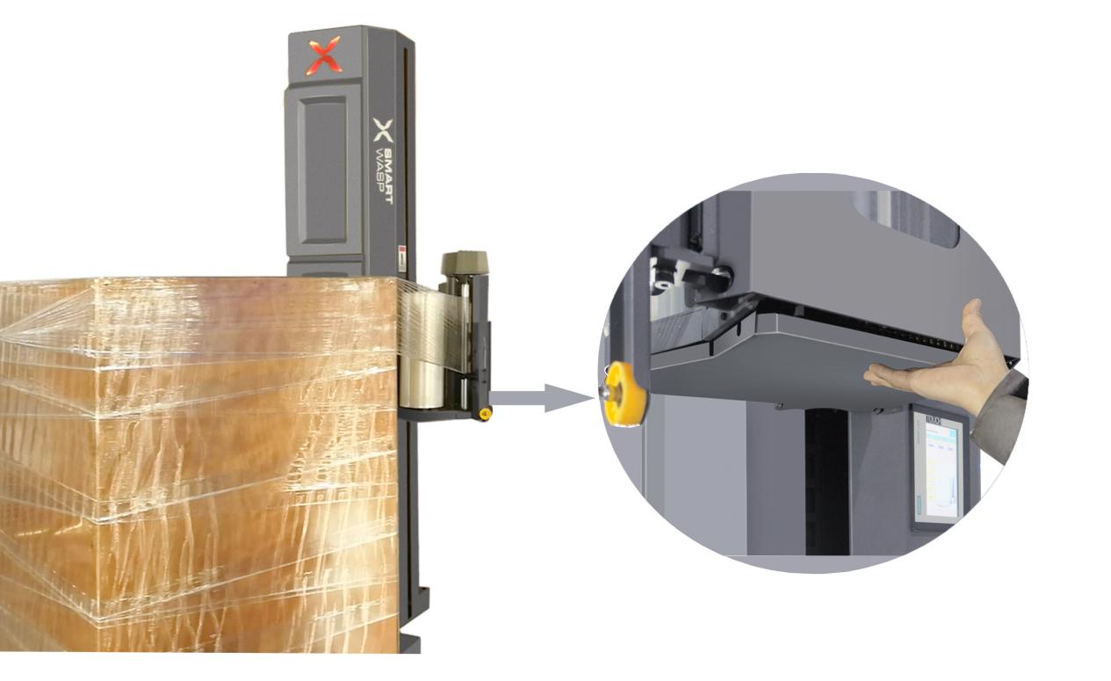

Film Carriage Bottom Safety Device

When workers head and foot touches the bottom of the film carriage,machine stops

and alarms.We care what you care about. Worker’s safety first.

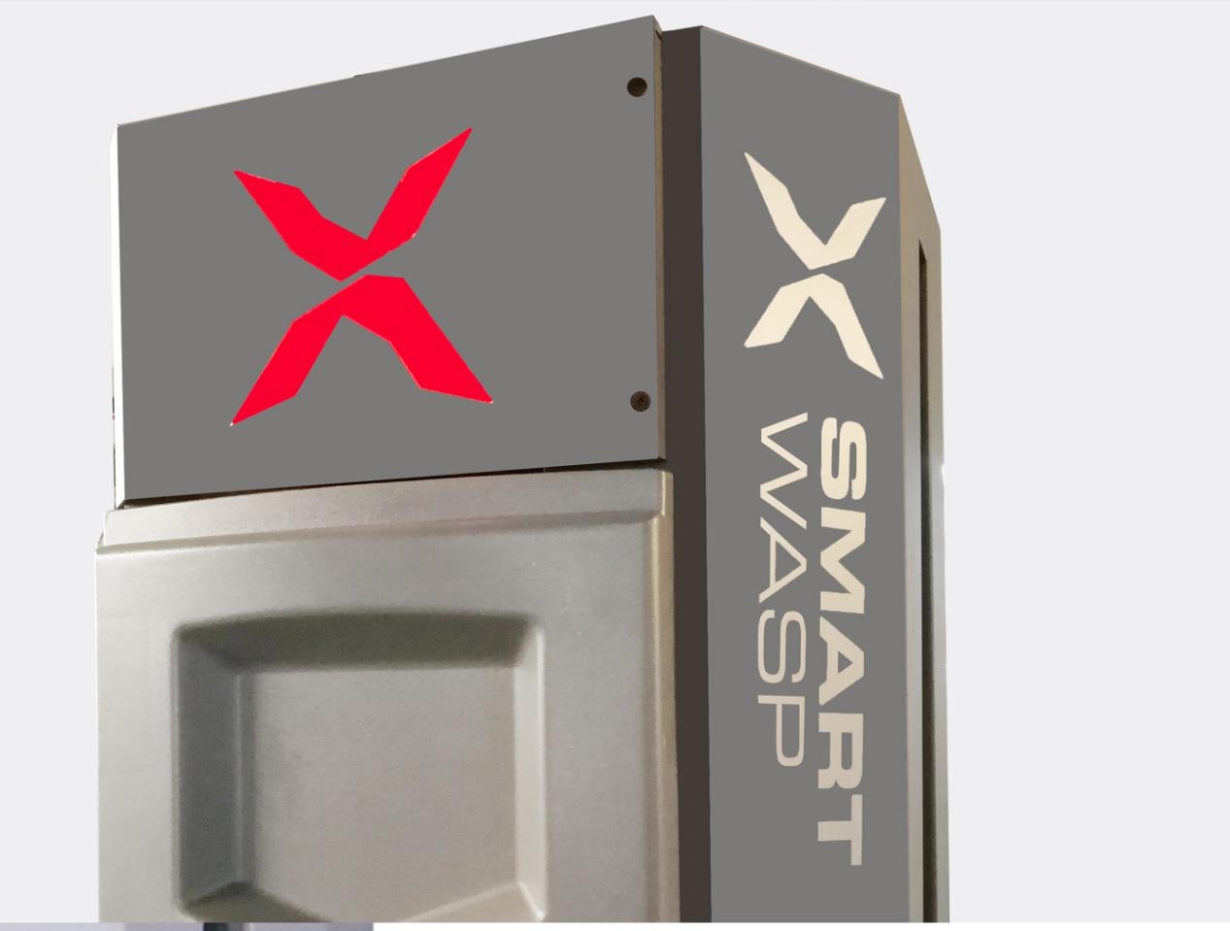

Intelligent Alarm system

When machine have error or the film consumed ,the machine will stop running and alarm to inform operator check machine or put new roll film on machine ,the alarm information show on the touch screen so that tell operator the alarm information directly .

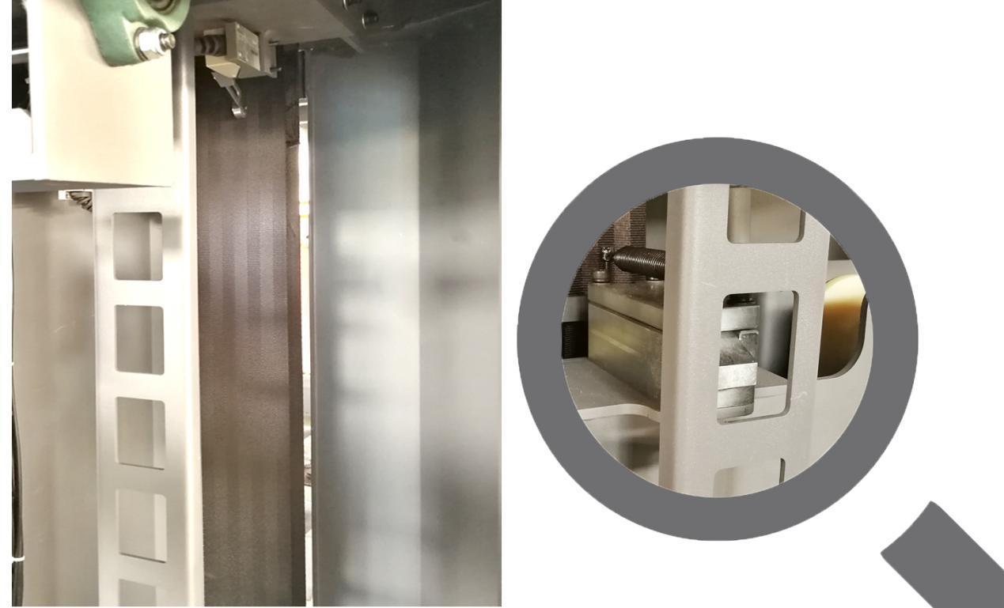

Film carriage Anti -Drop System

Smart Wasp series machine ,the film carriage system with the anti drop system.if the drive belt break,the anti drop system will catch the film carriage immediately so that avoid the film carriage fall down damage machine or hurt operator.

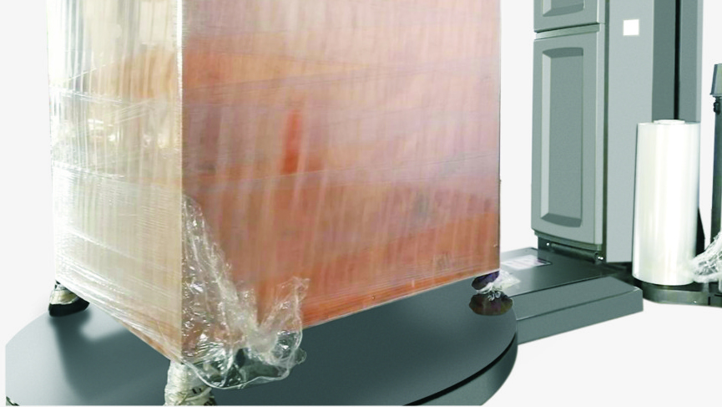

Automatic Cut film function

After Machine finish wrapping ,the tail of film will be cut automatic ,no need operator go to cut the film by hand .more convenient for the operator.

